REVIEW FOR WOMEN TAKING ORAL CONTRACEPTIVE PILLS

Name ………………………………………… Date of Birth ……………………………………….

Telephone Number which you are happy for us to contact you on …………………………………………

Date you need your next supply of contraceptives …………………………………………………………….

YOU NEED TO RETURN THIS COMPLETED FORM TO US AT LEAST
2 WEEKS BEFORE YOU NEED YOUR NEXT PACKET OF PILLS.

You have recently requested a repeat prescription for your contraceptive pills. We attach a prescription for one packet of your pills because your annual review is now due. If you have no problems with your contraceptive pill it may not be necessary for you to see the doctor and instead you may just complete this form fully and return it to us within the next two weeks. We do need to know your height, weight and blood pressure. You can check these without an appointment in the Health Information room at the Wycliffe Medical Practice- the room is open between 08.30 and 18.00 Monday - Friday. It should only take you five minutes!

Once we have processed the information on this form we will decide whether you can pick up a prescription for a further 12 month supply of pills, or whether the doctor wishes to see you - in which case we will contact you. It is helpful if we can have a mobile or home phone number on which you are happy for us to leave a message.

If you would rather see the doctor for your annual review, please make an appointment with the doctor of your choice, and bring the completed form to the appointment with you.

Name of the contraceptive you are taking…………………….…………………………………
If you are taking the combined (21 day) pill, is your bleeding regular? | YES | NO
Or
If you are taking the progesterone only pill (mini-pill) do you have any bleeding?  If you are taking the progesterone only (mini-pill) is this cycle acceptable? | YES | NO
 | YES | NO

 | NO | YES
Do you think you are getting any side effects from the pill?

Are you breast feeding?

Do you take drugs for epilepsy, Tuberculosis (TB) or HIV?

Do you take St John’s Wort?

Do you suffer from migraines?

If yes. Do your migraines provoke loss of visions, numbness, weakness or speech problems?

Do you have breast lumps that you have not seen a GP about?

Have you ever had breast cancer?

 | NO | YES
Do you have a genetic condition that predisposes you to breast cancer e.g. BRCA1 / BRCA2 ?

Do you have gallstones that cause you symptoms?

Have you ever had liver problems such as cirrhosis, liver cancer or liver problems related to taking the contraceptive pill?

Have you ever received an organ transplant?

Are you diabetic?

Do you have a history of high blood pressure?

Do you suffer from any form of heart disease?

Have you ever had a stroke / mini stroke (TIA)?

Have you ever had a blood clot in your leg or lung?

Has a close relative ever had a blood clot in the leg or lung?

If yes (and if known) what is their relationship to you?

And what age were they when they had their blood clot?

Do you smoke?
Never Smoked | Ex-smoker | Current smoker
 | How long ago did you stop? | How many do you smoke per day?

Please note - we advise all smokers that they should stop smoking. Smoking does increase the risks of circulatory problems, particularly in women on the pill. If you would like help to stop smoking please contact QUITREADY LEICESTERSHIRE on 0345 646 6666 or visit www.quitready.co.uk

More women are becoming interested in using long-acting reversible contraceptives such as coils, implants or injections.

This is contraception that you don’t need to remember - you can find details about them on the last page of this leaflet.

If you would like to consider one of these methods please make an appointment with your Doctor.

We do recommend that all women should be ‘breast aware’ – if you would like information about checking your breasts please pick up a leaflet from the health information room. If you think you have a breast lump, or you have a strong family history of breast cancer and have not previously discussed this, please make an appointment with your doctor.

Please staple
Blood pressure
print out here

Your Height ………………… (cm)
Please staple Blood Pressure printout here
Please staple Blood Pressure printout here
Please staple Blood Pressure printout here
Your Weight ………………… (Kg)

We usually prescribe 12 packets of the pill. If you want fewer packs please state the number required here:

Where would you like to collect your prescription from?

Wycliffe Medical Practice  Gilmorton Road  Monday – Friday ⁯ | Fortnams Pharmacy  High Street  Monday – Saturday ⁯ | Lloyds Pharmacy  Gilmorton Road  Monday – Friday ⁯

Other please specify:…………………………………………………..

Your signature: ………………………………………………………… Date:……………………………

Information regarding Long Acting Reversible Contraception.

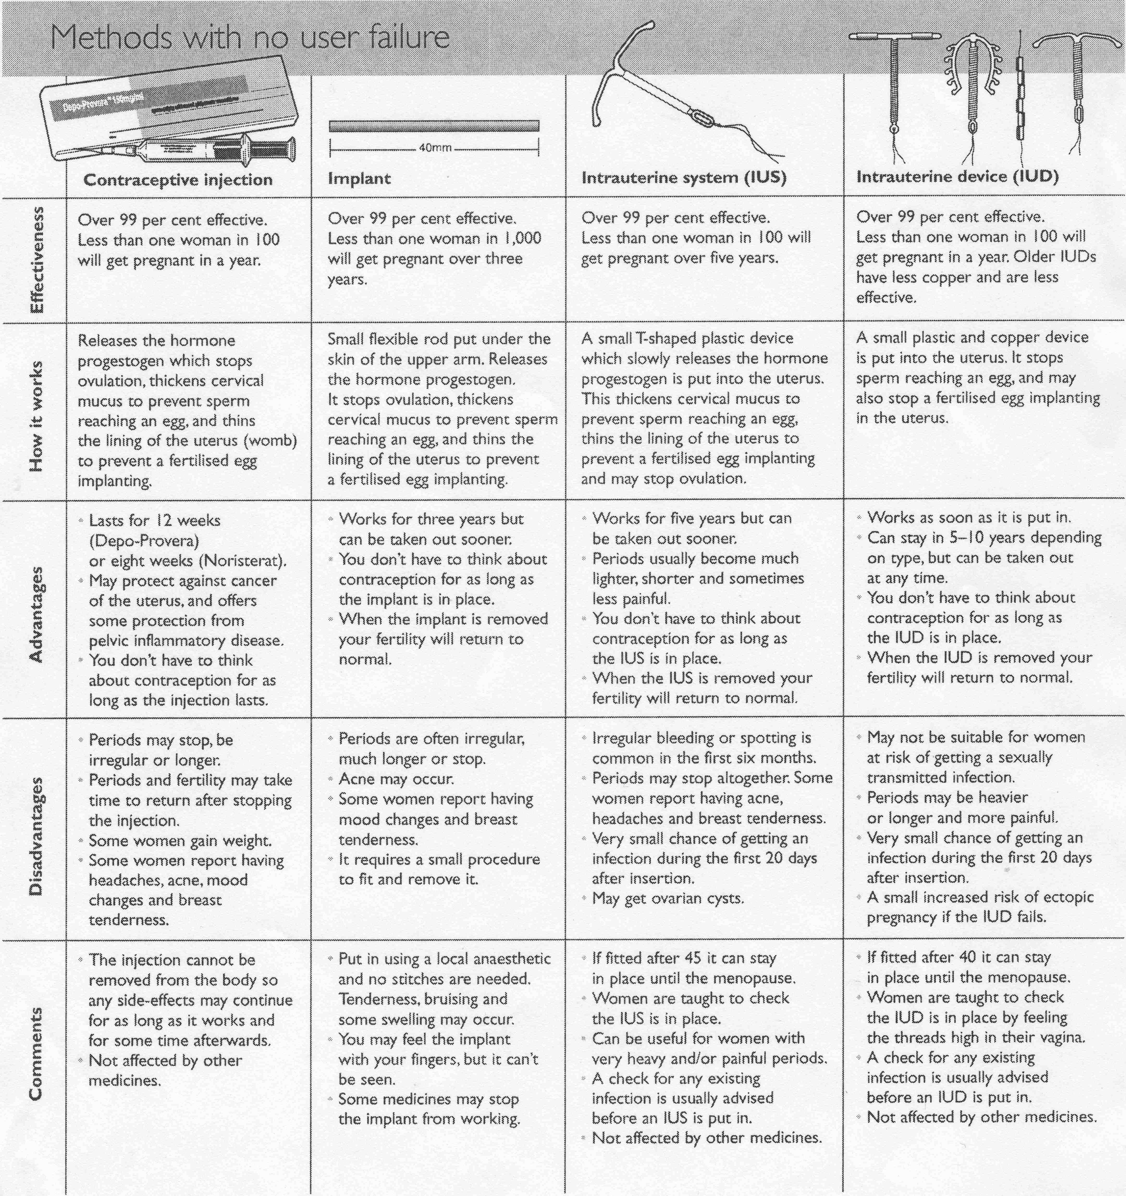

If you would like to consider one of these methods please make an appointment with your Doctor.

